FOSSILS

Fossils - the preserved remains, impression or traces of past life on Earth.

The formation of a fossil occurs in several steps.

• Dead organism is covered with sediments such as mud, silt or sand.
• Attack by decay organisms is slowed - more likely to have remains intact.
• Sediment is compressed by overlying layers - forms sedimentary rock.
• Fossils are trapped inside.
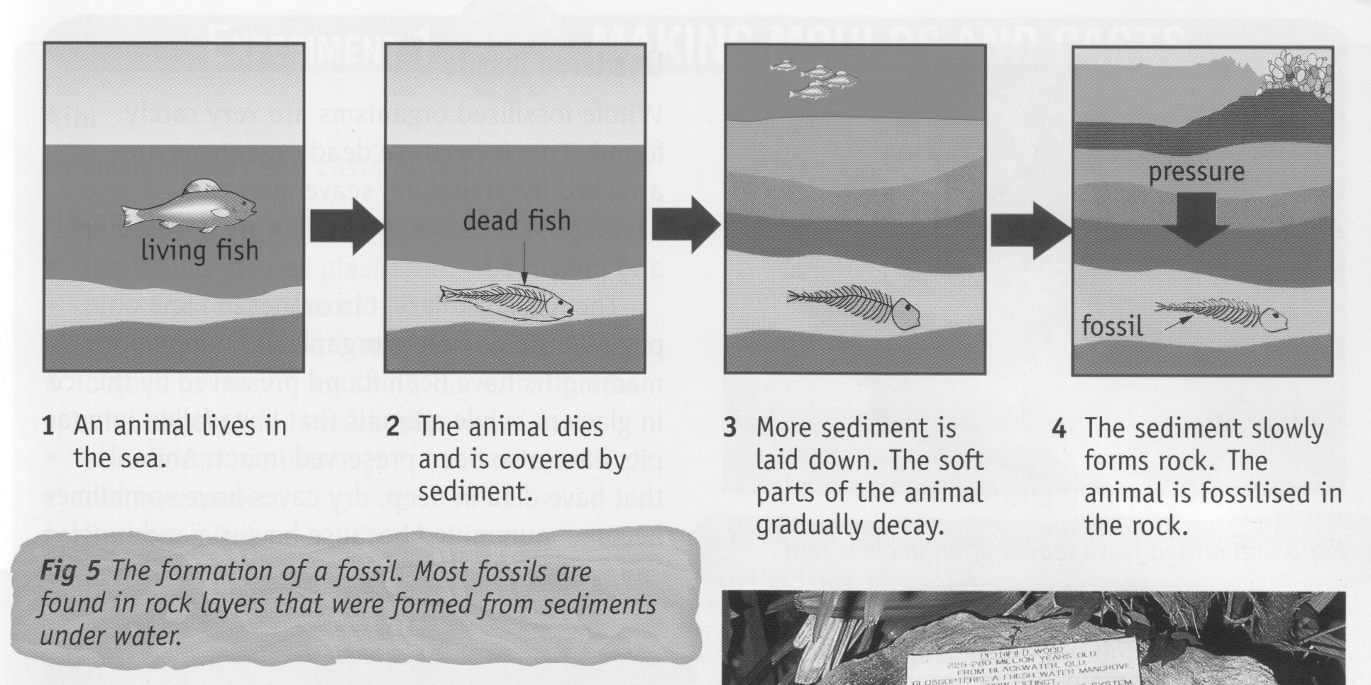

Petrified Fossils

• Formed when the bones, shells and other hard parts of the skeleton are replaced by
minerals from the surrounding rock.
• Takes millions of years.
• Process is called petrification.

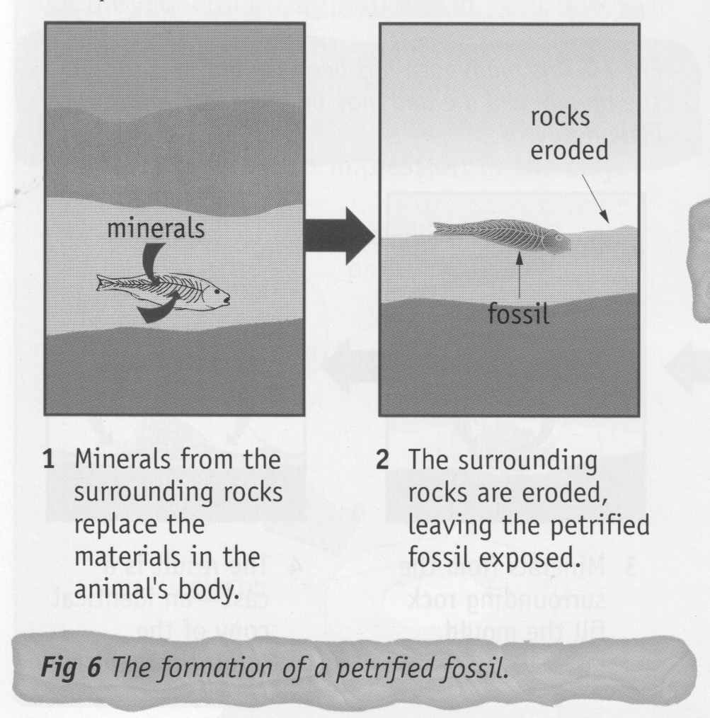
Carbonised Fossils

• Extreme heat and pressure changes all the chemicals in the organism's body, except
carbon.
• Fossil is black in colour.

Moulds and Casts

• Organism decays inside the rock.
• Leaves a cavity called a mould.
• Minerals from surrounding rock can seep into the mould and form a cast - a copy of the
original organism.

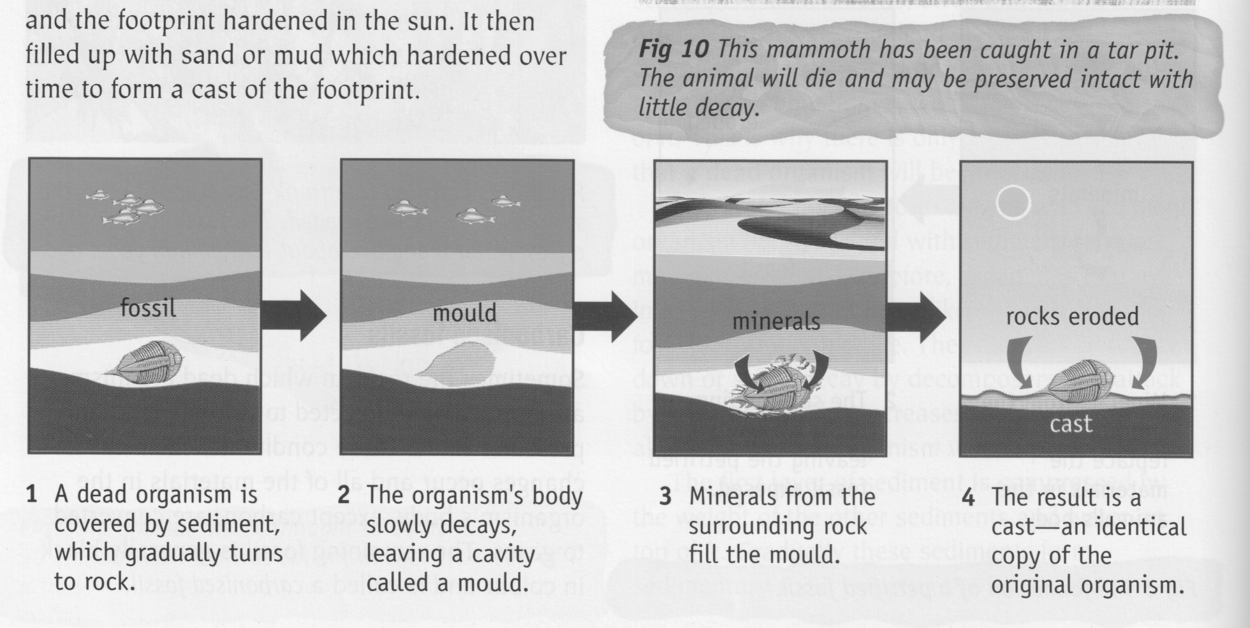

Unaltered Fossils

• Whole organisms are very rare to find.
• Possible if the organism is covered quickly.

e.g. Insect covered by tree sap - becomes amber.
Woolly mammoth found preserved in ice or tar pits.

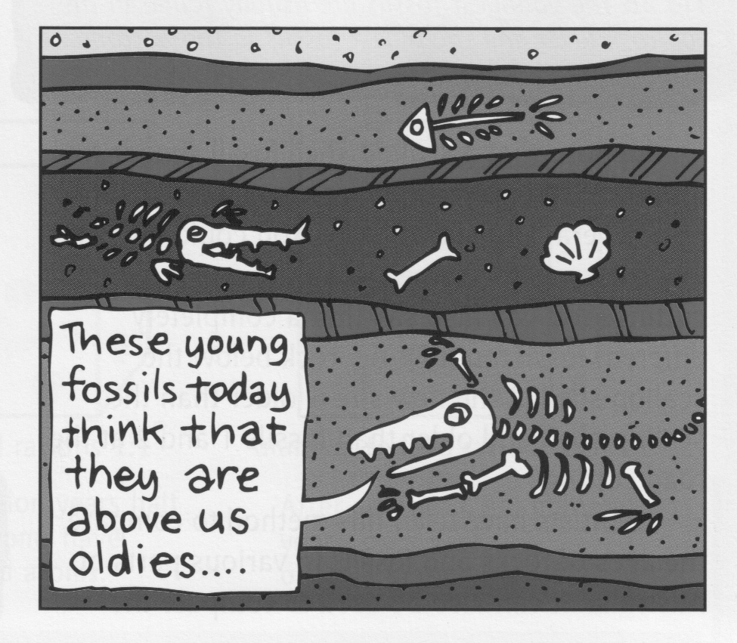
The Age of Fossils

Relative Age - young fossils occur on top of older
ones.

Absolute Age - fossils are the same age as the
surrounding rock.

